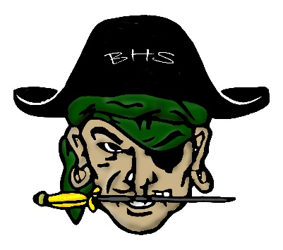
BURNEY HIGH SCHOOL
2022 Volleyball Schedule

Day | Date | Opponent | Location | Time
Tuesday | August 30 | Trinity# | Trinity | 5:00 p.m.
Thursday | Sept. 1 | Hayfork# | Burney | 5:00 p.m.
Tuesday | Sept. 6 | Surprise Valley# | Burney | 5:00 p.m.
Thurs-Sat. | Sept. 8-10 | Emblem F Tournament | Fall River | TBA
Thursday | September 15 | Maxwell# | Burney | 5:30 p.m.
Tuesday | September 20 | Chester* | Burney | 5:30 p.m.
Thursday | September 22 | Quincy* | Quincy | 5:30 p.m.
Tuesday | September 27 | Redding Christian* | Burney | 5:30 p.m.
Thursday | September 29 | Portola* | Portola | 5:30 p.m.
Saturday | October 1 | Burney Tourney | Burney | TBA
Tuesday | October 4 | Bye
Thursday | October 6 | Chester* | Chester | 5:30 p.m.
Tuesday | October 11 | Quincy* | Burney | 5:30 p.m.
Thursday | October 13 | Redding Christian* | Redding Christian | 5:30 p.m.
Tuesday | October 18 | Portola* (Senior Night) | Burney | 5:30 p.m.
Thursday | October 20 | Tulelake# | Tulelake | 4:00 p.m.
Tuesday | October 25 | NSCIF Playoffs | TBA | TBA
Thursday | October 27 | NSCIF Playoffs | TBA | TBA
Tuesday | November 1 | NSCIF Playoffs | TBA | TBA
Saturday | November 5 | NSCIF Championships | TBA | TBA
#Non-League Matches *League Matches

Varsity Coach: Johanna Crabtree Phone No: (530) 335-4576
J.V. Coach: Amanda Tate Fax No: (530) 335-3554
Principal / AD: Ray Guerrero Mascot: Raiders
Colors: Green & Gold

